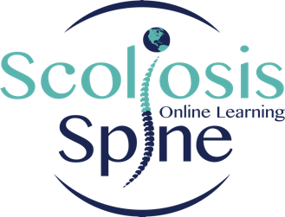

SSOL Application Form for Practical Part 2 (PP2)

Personal
Full name
Credentials
PT License #
Cell
Home address
Personal email
Years of practice as PT
Do you have scoliosis?
Will you be willing to bring a patient to be a model?

Work
Work/clinic name
Address
Phone #
Work email
Years at current job

Scoliosis Education and experience
Scoliosis School name and level of course/s
Teacher/s
How many hours a week treating patients with scoliosis and at what age?

SSOL Ethics Form for Practical Part 2 (PP2)

I understand that completion of PP2 course does not guarantee PP2 certification, and that in order to obtain certification, I must pass the SSOL PP2 practical examination. If I fail to pass the PP2 examination I will be required to retake the practical exam withing 3 months from completion of the course. The practical exam can be taken at any location. If I fail the second time I understand that I will have to retake the entire course at full cost before retaking the PP2 certification exam again.

I agree that I will not provide lectures for the purpose of training others to use Schroth therapy for patient care. I understand that I may provide lectures for the purpose of promoting my therapy services, and for educating the public, other professionals, and university students on scoliosis conservative management and Schroth principles for general purposes only.

If I am a Clinical Instructor for physical therapy students, I agree that my students will be able to observe me providing Schroth therapy.

I agree to sign the SSOL Ethics of Practice Agreement.

_____________________ _______________________ _________________
Full Name Signature Date

Course Fee: PP1 - $2,500
Course payment is due in full at the time of registration. Course may be paid by Zelle or PayPal (using hagitberdi@gmail.com), Venmo (using @hagit-berdishevsky) or bank wire.

CEU: This course is allegeable for 45 CEUs

Course Location:
SchrothNYC Studio - 16 East 96th Street 1B, New York, NY 10128

Course Application: to be emailed to: hagitberdi@gmail.com

Course Cancellation Policy:
Due to the involved nature of course organization, cancellation policy is as follows:
- If registrant cancels with less than 30 days notice:
- If cancelled spot is filled with another attendee, a refund will be issued, less 10% service charge
- If cancelled spot is not filled, there will be no refund of course fees.
2. If registrant cancels with more than 30 days notice:
- Refund will be issued, less 10% service charge
3. We reserve right to cancel the course at any time due to low attendance or other conflicts.
- Should the course be cancelled by instructors, full refunds will be issued.

